Le Chéile Mentoring
Board of Directors Recruitment Booklet
April 2023

- Background
Le Chéile Mentoring is a national, volunteer mentoring and family support service, which works with young people and their families, where the young person is involved in or at risk of offending. We achieve this through youth and parent mentoring, family support and restorative justice services. We provide tailored and flexible services with young people at the core.

Our vision is for every young person at risk – the right supports at the right time, to make the most of their lives.

Le Chéile recruits, trains and supports volunteers from local communities around Ireland who act as positive role models and provide a supportive relationship for the young person. Each week mentors and young people meet and work together on goals, supporting the young person in their community. Established in 2005, we work in partnership with the Probation Service, the Gardaí and other organisations to reduce the level of crime in the community.

Le Chéile is governed by a Board of Directors and is structured as a company limited by guarantee. Le Chéile is a registered charity (RCN: 20066000) with the Charity Regulator and has been granted Charitable Tax Exemption from Revenue (CHY No. 17621).

The company is managed and led by the CEO reporting to the Board of Directors. Le Chéile is funded by the Probation Service, the Department of Justice, Victims of Crime Office and Limerick City Council.

- Services and Locations
Our services include Youth and Parent Mentoring, Restorative Justice and Family Support. Our services span 10 counties as can be seen below. We employ over 20 staff and there are about 230 volunteers involved in delivering mentoring.

For more information visit www.lecheile.ie

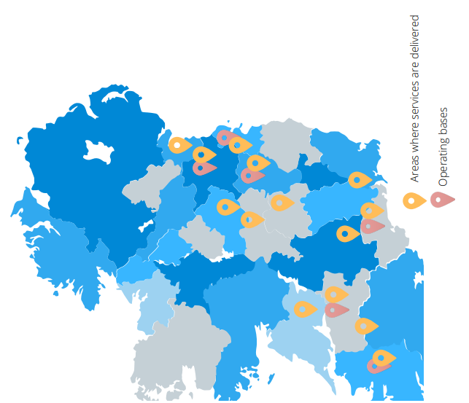

- Board Vacancy Details
Le Cheile is seeking 3 new Directors who are interested in making a difference to the lives of vulnerable young people and their families. A strong and effective Board of Directors is essential to Le Cheile being able to provide high quality services to the young people and families that we work with.

We are recruiting 3 new Directors as follows:
- A person with HR expertise who can strengthen the Board’s knowledge and oversight of this key area. This role will play a key role is supporting the CEO and advising the Board in relation to HR matters.

Role Description:
Provide expertise and advice relating to HR to the Board.
Take an active role in the Finance and HR subcommittee of the Board.
Support the CEO in relation to HR matters.

- A person with Management experience, Communications and Marketing skills with a focus on online and traditional media. This role is actively involved in the organisation’s strategic direction, taking a leading role on communications and PR development.

Role Description:
Be an active contributing Director of the Board.
Provide expertise and advice on all matters relating to communications, marketing, public relations and digital development.
Advise on the implementation of communications strategies.
Take an active role in the Fundraising and Communications subcommittee of the Board.

- A person with Business/Strategy/Governance expertise. This person will have experience of operating at a senior level and be capable of contributing to Board’s core functions in particular in relation to strategy, finance, compliance and risk management.
This role will be expected to be an active contributing Director of the Board and to take an active role in one of the subcommittees of the Board.

Closing date for receipt of applications is: 9am May 15th 2023

- Roles and Responsibilities of Le Chéile Board of Directors
The Board meets approximately 8 meetings per annum, plus attendance at sub-committee meetings, as required. Meetings are held on Tuesday evenings in our head office in Dun Laoghaire. A hybrid approach is being implemented at present which will facilitate meetings in person with the option of joining remotely.

As a registered charity no fees are paid to Board members. Travel and subsistence expenses are paid where appropriate. The term of office is three years, with the option of reappointment.

The main responsibilities of the Directors are set out below.

Vision and Leadership
The Board will review and ensure the relevance of the vision, mission, values and strategic direction of the organisation. The Board will ensure that organisational activity supports its ethos, vision, purpose and aims.

Accountability
The Board will account for everything the organisation does, including its spending and activities. The Board is accountable to all key stakeholders such as funders and donors, and the target group. The Board monitors and evaluates all areas of the organisation’s performance.

Legal Matters
The Board will ensure compliance with all relevant legal and regulatory requirements and will seek guidance around any uncertainties. All activities and processes of the Board and the organisation will be in-line with its governing document, i.e., the Company Constitution.

Financial Responsibilities
The Board will ensure that all money, property and resources are properly used, managed and accounted for. In order to be accountable, suitable systems must be in place and kept up to date.

Managing Staff and Volunteers
The Board has full responsibility as an employer. This involves ensuring that appropriate policies and procedures are in place for staff and volunteers, and that staff are properly managed and supported. In Le Chéile, the Board delegates the implementation of employment related, HR and volunteer policies to the CEO.

A list of the fiduciary duties of an individual company director and charity trustee are listed in Appendix 1.

Maintaining Board Confidentiality
From time-to-time Board members/trustees will be involved in activities either at Board meetings or on behalf of the Board which call for tact, discretion and above all, confidentiality. The proceedings of all such meetings are confidential to those taking part.

Successful applicants will be provided with induction training as appropriate.

- Board Sub-Committees
Le Cheile has in place a number of sub-committees who assist the work of the Board.

The Finance and HR Sub-Committee
The role of the Finance and HR Sub-Committee is to address issues relating to Funding, Finance, Budgets, Audit, HR, Recruitment and Staffing Issues and to report its recommendations to the Board.

The Governance Sub-Committee
The principle purpose of the Governance Sub-Committee is to ensure good corporate governance.

The Communications and Fundraising Sub-Committee
The purpose of the Communications and Fundraising Sub-Committee is to support and promote the fundraising, communications, and public relations strategies of the organisation.

- Person Specification
Candidates for Board membership must demonstrate that they have an understanding of the core values of the Board of Le Chéile; and that they possess the essential knowledge, skills and experience of governance required for board membership.

6.1 Core Values
In executing the main object of the company, Le Chéile Mentoring are looking for candidates that can demonstrate the following core values:

Public Service: Board members should act solely in terms of the public interest. They should not do so in order to gain financial or other benefits for themselves, their family or their friends
Integrity: Board members should not place themselves under any financial or other obligation to outside individuals or charities that might seek to influence them in the performance of their official duties
Objectivity: In carrying out public business, including making public appointments, awarding contracts, or recommending individuals for rewards and benefits, board members should make choices on merit.
Accountability: Board members are accountable for their decisions and actions to the public and must submit themselves to whatever scrutiny is appropriate to their office.
Openness: Board members should be as open as possible about all the decisions and actions that they take. They should give reasons for their decisions and restrict information only when the wider public interest clearly demands.
Honesty: Board members have a duty to declare any private interests relating to their public duties and to take steps to resolve any conflicts arising in a way that protects the public interest
Leadership: Board members should promote and support these core values by leadership and example.

  - Skills Required of Board Members
The following criteria are desirable for the role of a Board member with Le Chéile Mentoring

- Demonstrated knowledge of the community & voluntary sector and/or publicly funded bodies
- Senior Management / Leadership Experience
- Previous Board or committee experience
- Good knowledge of Corporate Governance

The following additional competencies are considered beneficial:
- Legal and compliance
- Change Management
- Data Protection
- Health & Safety

- Application Process
Having considered the general suitability criteria for membership of the Le Chéile Mentoring board, you should consider how your background and experience fits with the specific appointment criteria set out in the person specification above.

Please consider the possibility of any potential conflict of interest that may arise if appointed to this board.

Please email your expression of interest application to: anneconroy@lecheile.ie

Please type ‘EOI for position of Director” in the subject line of the email.

Closing date for receipt of applications is: 9am May 15th 2023

Our assessment of your application will:
- Review and discuss the expressions of interest received against the specific appointment criteria for the role, as advertised in this Information Booklet;
- Assess potential candidates further once they meet the specified appointment criteria by undertaking any or all of the following steps:
  - Consideration of the written applications; and/or
  - Meeting/conference call; and/or
- Reference checks; and/or any other selection or verification method deemed appropriate.
- Arrive at a shortlist of the most suitably qualified candidates (based on the information provided by the candidate) to be sent forward for consideration by the full Board.

If you have any queries, please email the CEO anneconroy@lecheile.ie

- Confidentiality of Applications
Subject to the provisions of the Data Protection Act 2018 and GDPR, all applications will be treated in strict confidence. All enquires, applications and all aspects of the proceedings are treated as strictly confidential and are not disclosed to anyone, outside those directly involved in that aspect of the process.

Should more than 2 candidates be deemed suitable for appointment, the Board may form a panel for any future vacancies in the following 12 months, or a candidate may be offered a position on a board sub-committee as an external member.

Thank you for your interest in Le Cheile Mentoring!

Appendix 1
Role of Individual Charity Directors
The eight principal fiduciary duties of directors are set out in the Companies Act as follows:
1. Act in Good Faith
Each Director is obliged to act in good faith in what the Director considers to be the best interests of the company. This is a subjective test and recognises that two Directors can have two different but equally legitimate opinions as to what constitutes the best interests of the company.
2. Act Honestly and Responsibly
Directors must act honestly and responsibly in relation to the conduct of the affairs of the company. While this was not a common law duty, it was deliberated on by the courts on numerous occasions in the context of imposing restrictions on Directors.
3. Act within Powers
Directors must act in accordance with the company’s constitution and exercise his or her powers only for the purposes allowed by law.
4. Use of Company Property
A Director is not permitted to use the company’s property, information or opportunities for his or her own or anyone else’s benefit unless this is expressly permitted by the company’s Constitution or the use has been approved by a resolution of the company in a general meeting.
5. Independent Judgement
A Director shall not agree to restrict his or her power to exercise independent judgement unless this is expressly permitted by the company’s constitution; or the Director believes, in good faith, that to fetter his or her discretion is in the best interests of the company.
6. Avoid Conflicting Interests
A Director is obliged to avoid any conflict which may arise between the duties the Director owes to the company and the Director’s other (including personal) interests unless the Director is released from his or her personal duty to the company in relation to the matter concerned by virtue of either the provisions of the company’s constitution or by a resolution in a general meeting.
- Due Care, Skill and Diligence
A Director must exercise the care, skill and diligence which would be exercised in the same circumstances by a reasonable person having the knowledge and experience that may reasonably be expected of a person in the same position as the Director; and who also possesses the equivalent level of knowledge and experience which the Director has. This sets a quasi-objective standard by which a Director should be judged. While it does use the ‘reasonable man’ test, that man is taken to be a person with the director’s knowledge and experience.
8. Regard to Members’ Interests
In addition to the general duty as referred to above, Directors have a fiduciary duty to have regard to the interests of the members of the company.

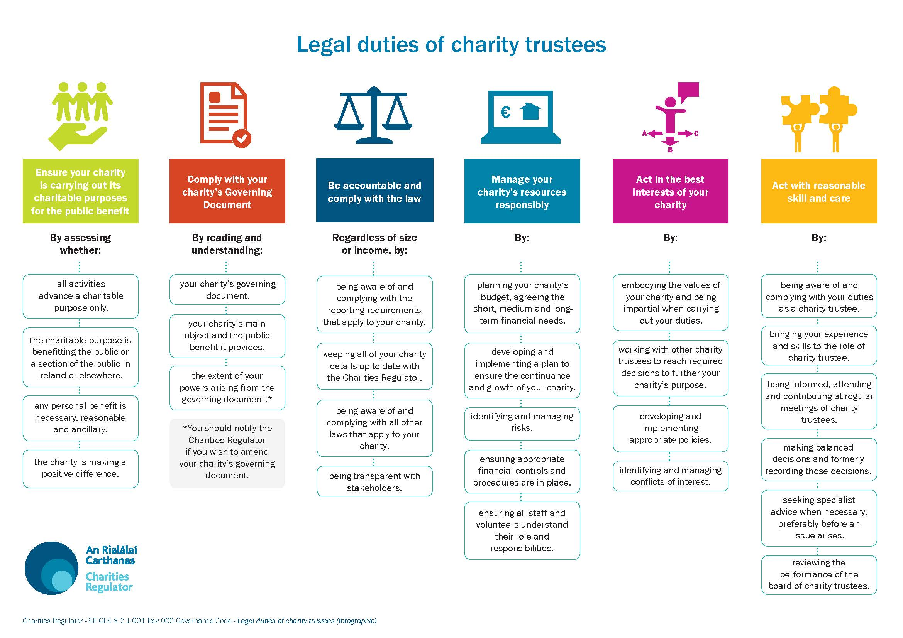
Le Chéile Mentoring – Organisational Structure April 2022